**4435 – Project 1 – Online TODO App**

In This Project, You’ll Create An Online TODO App (Online Services Are Provided By Me)

Using Scenario :

When You Open Your App, You’ll Have A Login Screen. From This Screen User Can Log In To Your App, Or Open The Registration Screen By Clicking Register Button.

For The Login, User Just Need To Enter Username & Password Data and Click Login Button.

For the Registration User Need to Enter Following Data :

Username, Password, Phone, Country and Display Name.

After Filling This Form, User Will Click Register.

If Registration Is Successful, You’ll Redirect User To Login Page To Let Him Sign In.

When User Is Logged In, User Will Be Redirected to PostList Screen.

If User Logged In Before, When You Open Your App, User Must Be Redirected To Post List Screen Automatically (You Can Use Shared Preferences To Store User Data)

In Post List Screen You’ll Have A List View To Show Posts That User Added.

From The ActionBar Menu When User Clicks [+] (Add Post) Button, User Will Be Redirected To Another Page In Which He Can Enter Post Data (As Title and Text) And Send It To Server.

When Post Added, User Must Be Automatically Redirected to Post List Screen And Contents Must Be Refreshed Automatically.

When User Long Clicks A Post From The Post List, An Alert Dialog Must Be Shown To User For The Delete Confirmation . If User Confirms Deletion, That Post Must Be Deleted And List Content Must Be Refreshed.

If User Selects Log Out From ActionBar Menu. Your Application Must Clear Any Stored Data About User Account, And Redirect User To Login Page.

Also There Will Be A Button On ActionBar Like Account Info. When User Clicks This, User Will Be Redirected To A New Screen In Which He Can See His Account Information And Change His Password.

You Will See Something Called Student Hash On Service Definitions. For This Hash Value Just Send Your Student Id (Always Same)

Web Service End Point : https://tux.csicxt.com/index.php

Shash (Student Hash) : Please Use Your Own Student Id For This Value All The Time

To Register You Must Send A Request Like The Following :

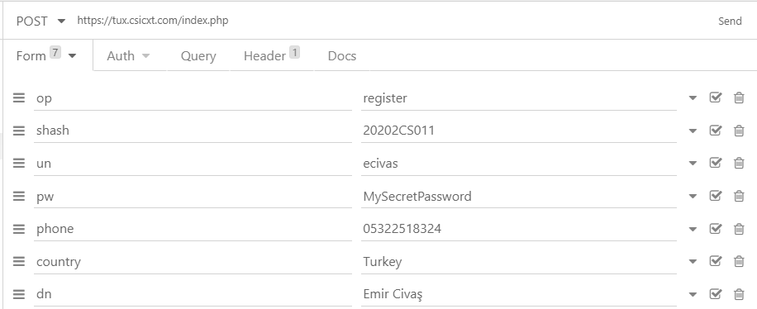

If Registered Successfully, You’ll Have This Reponse :

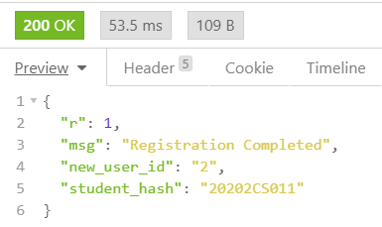

If That User Is Already Registered, You’ll Have This Repsonse :

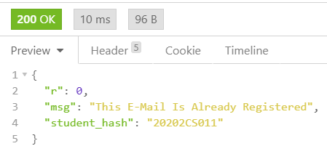

To Login, You Must Send A Request Like The Following :

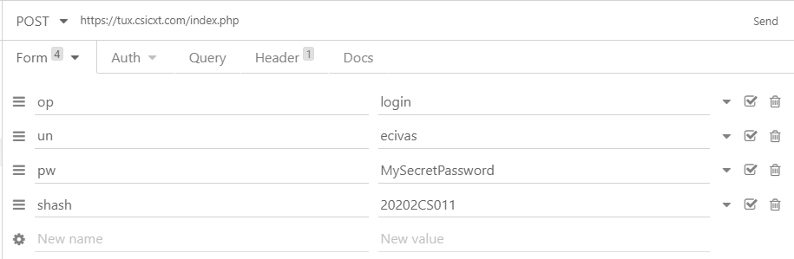

If Your Credentials Are Correct, You’ll Have This Response :

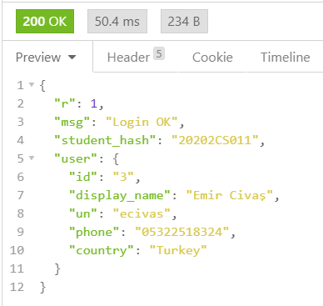

If Not, You’ll Receive This Response :

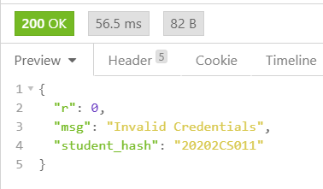

To Change Your Password, You Must Send A Request Like This :

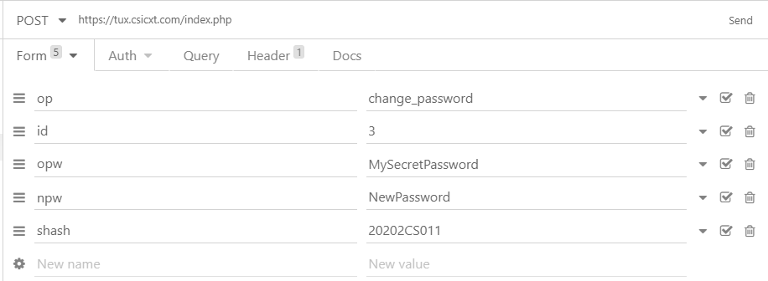

If Your Password Is Changed, You’ll Have This Response :

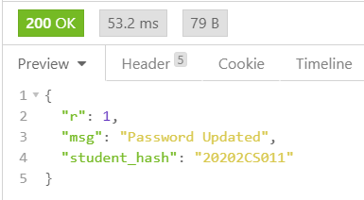

If Your Current Password Or Any Other Info Is Incorrect, You’ll Have This Response :

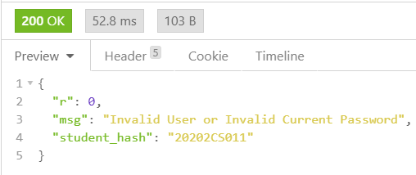

To Get List Of Posts That You’ve Added :

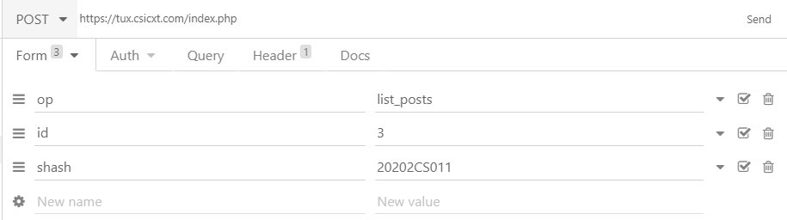

And You’ll Receive A JSON Array Like This : (Ofcourse At The Beginning It’ll Return An Empty Array)

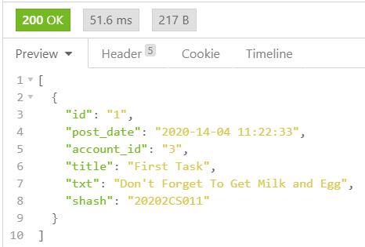

To Add A Post :

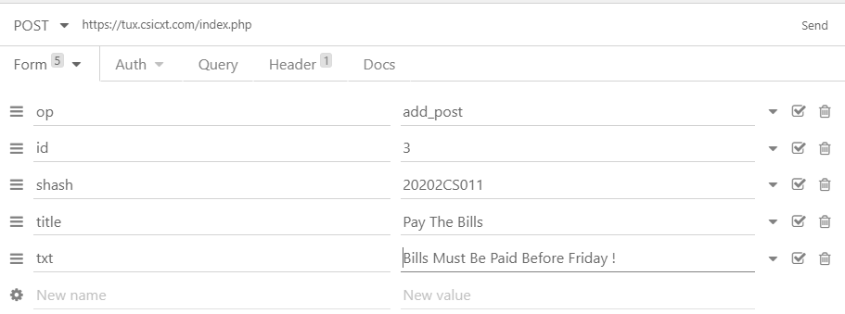

If Post Added Successfully, You’ll Have This Response :

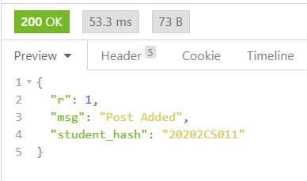

To Delete A Post : (Account Id , The Id You Got When You Logged In, post_id : The Id Of Post Which You Want To Delete, You Can Get This From List Posts)

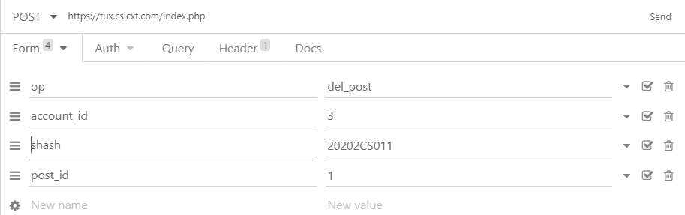

After Sending A Delete Post Request (Correctly) You’ll Have This Reponse :

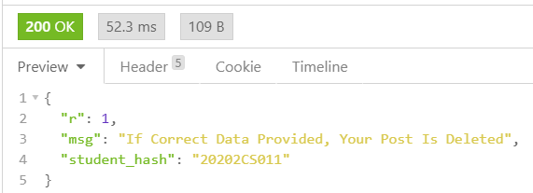

PROJECT DEADLINE

10.12.2020 23:50

**Information About Project Delivery**

As Stated In Course Syllabus, You Will Have 2 Individual Projects (Each Of Them Will Be 15% Of Your Course Grade). This Document Includes A Brief Explanation About How To Create & Compress Those Projects.

For Each Project, Project Name Must Be Like Following :

**PRJ_(1|2|3)_STUDENT_ID** For Example **PRJ_1_123456**

Package Name Of Your Project Must Be Like Following :

**prj_(1|2|3).stu_STUDENT_ID** For Example **prj1.stu_123456**

Projects Will Use Java Language (Not Kotlin) and Minimum SDK Will Be API 23 (Android 6.0)

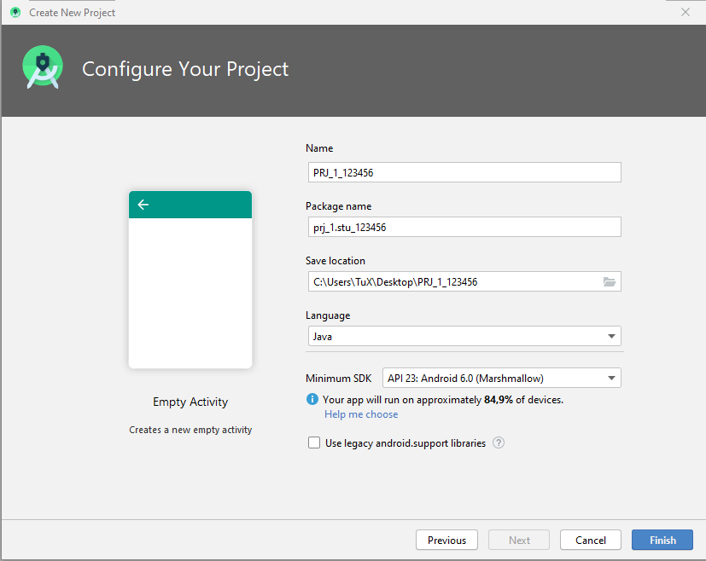

While Sending Your Project, You Must Send A Zip File (With: PRJ_1_STUDENT_ID.zip) Which Contains Only 2 Main Entries :

**PRJ_(1|2|3)_STUDENT_ID** -> Android Project Folder

**PRJ_(1|2|3)_STUDENT_ID.apk** -> Runnable, Android Application Package

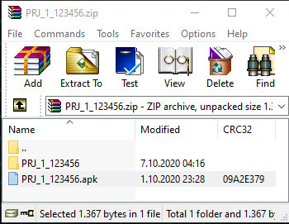

It’s Your Responsibility To Create, Pack And Upload Your Projects As Requested Format. If You Don’t, The Files You’ve Sent Will Be Neglected, And You’ll Get 0 For That Project.

If You Miss Deadline For Uploading A Project, You’ll Also Get 0 For That Project. (If You’re Having An Inevitable Excuse And Tell Me Before Deadline, I Might Give You Extra Time)

Your Will Deliver Your Project Via ItsLearning Platform.